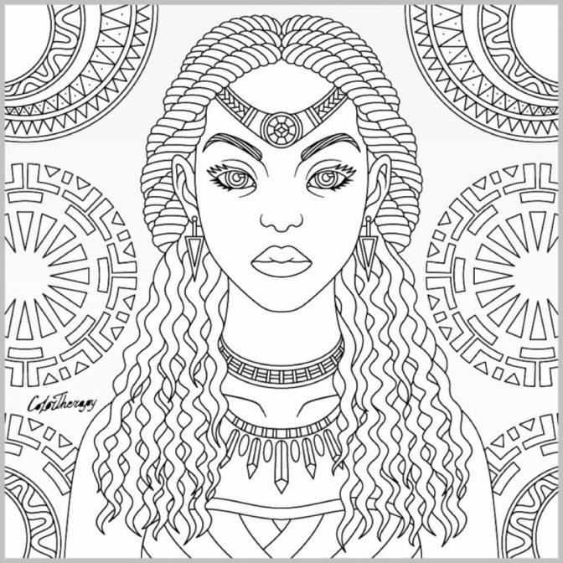
Colour in and decorate the queen of Sheba, with metallic paper and gems.

Message: The Queen of Sheba from Ethiopia heard of all the wonders of King Solomon’s success and travelled to Jerusalem to see Solomon for herself. She wore beautiful beads and gold made from Ethiopia in Africa and gave lots of fine spices, gold and precious stones from Ethiopia to King Solomon as a gift. (2 Chronicles Chapter 9 vs 1-12).

Colour in and decorate the queen of Sheba, with metallic paper and gems.

Message: The Queen of Sheba from Ethiopia heard of all the wonders of King Solomon’s success and travelled to Jerusalem to see Solomon for herself. She wore beautiful beads and gold made from Ethiopia in Africa and gave lots of fine spices, gold and precious stones from Ethiopia to King Solomon as a gift. (2 Chronicles Chapter 9 vs 1-12).

Colour in and decorate the queen of Sheba, with metallic paper and gems.

Message: The Queen of Sheba from Ethiopia heard of all the wonders of King Solomon’s success and travelled to Jerusalem to see Solomon for herself. She wore beautiful beads and gold made from Ethiopia in Africa and gave lots of fine spices, gold and precious stones from Ethiopia to King Solomon as a gift. (2 Chronicles Chapter 9 vs 1-12).

Colour in and decorate the queen of Sheba, with metallic paper and gems.

Message: The Queen of Sheba from Ethiopia heard of all the wonders of King Solomon’s success and travelled to Jerusalem to see Solomon for herself. She wore beautiful beads and gold made from Ethiopia in Africa and gave lots of fine spices, gold and precious stones from Ethiopia to King Solomon as a gift. (2 Chronicles Chapter 9 vs 1-12).

Colour in and decorate the queen of Sheba, with metallic paper and gems.

Message: The Queen of Sheba from Ethiopia heard of all the wonders of King Solomon’s success and travelled to Jerusalem to see Solomon for herself. She wore beautiful beads and gold made from Ethiopia in Africa and gave lots of fine spices, gold and precious stones from Ethiopia to King Solomon as a gift. (2 Chronicles Chapter 9 vs 1-12).

Colour in and decorate the queen of Sheba, with metallic paper and gems.

Message: The Queen of Sheba from Ethiopia heard of all the wonders of King Solomon’s success and travelled to Jerusalem to see Solomon for herself. She wore beautiful beads and gold made from Ethiopia in Africa and gave lots of fine spices, gold and precious stones from Ethiopia to King Solomon as a gift. (2 Chronicles Chapter 9 vs 1-12).

Colour in and decorate the queen of Sheba, with metallic paper and gems.

Message: The Queen of Sheba from Ethiopia heard of all the wonders of King Solomon’s success and travelled to Jerusalem to see Solomon for herself. She wore beautiful beads and gold made from Ethiopia in Africa and gave lots of fine spices, gold and precious stones from Ethiopia to King Solomon as a gift. (2 Chronicles Chapter 9 vs 1-12).

